# **Classroom Expectations:**

* Arrive to class on time and be prepared every day.
* No food or drinks are allowed inside the classroom except for water.
* Cellphones, earphones, headphones, and phone charging are not permitted.
* Use Chromebooks only when asked to do so.
* Students may not leave for the bathroom or outside during the first 30 minutes and last 30 minutes of class.
* During discussions, refrain from causing disturbances and avoid standing. Raise your hand to ask questions or express concerns related to the topic.
* When participating in group work, actively engage and collaborate with your groupmates instead of solely depending on them.
* Submit the exit ticket as a brief daily assessment.
* Wait for the teacher to dismiss your seat group/row before leaving the class.
* Show respect for the learning environment and everyone in it at all times.

**Daily Progress Report**

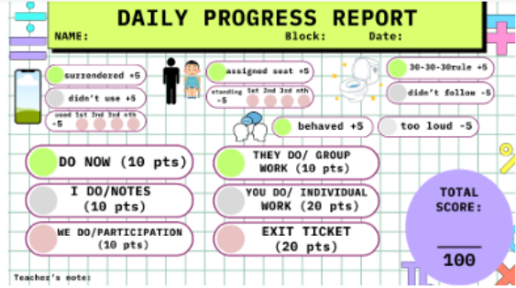

# **Grading Scale:**

9

**Consequences:**

1. Redirection/Record Incident in Educator’s Handbook
2. Parent phone call/conference
3. Report to Office/Administration
4. Admin + Parent Conference
5. ISS/OSS